**AUTOMATED EMBRYO GRADING FOR IVF TECHNOLOGY**

Project Report

Submitted in partial fulfillment of the requirements for the degree of

**B.E. (Information Technology)**

by

**CHAITRA RAO** (151106050)   
**NIKITA RAWAT** (151106050)

**SAHIL BLOWDA** (151106053)  
**SHALAKA KERKAR**(151106019)

Guide: Mr. AMOGH SANZGIRI



Information Technology Department   
Goa College of Engineering   
(Government of Goa)   
Goa University   
(2018-2019)

**APPROVAL SHEET**

This is to certify that  
**CHAITRA RAO** (151106050)   
**NIKITA RAWAT** (151106050)

**SAHIL BLOWDA** (151106053)  
**SHALAKA KERKAR**(151106019)

Have been admitted to the candidacy of B.E. (Information Technology) in December/January 2019 and they have undertaken the project entitled “**Project Title**” which is approved for the degree of B.E. (Information Technology) under Goa University as it is found satisfactory. (12)

Dr. Nilesh B. Fal Dessai Mr. Amogh Sanzgiri  
  
(Head of Department) (Project Guide)

(Internal Examiner) (External Examiner)  
Name: Name:  
Designation: Designation:

DATE:

PLACE: Farmagudi

**GOA COLLEGE OF ENGINEERING**

(GOVERNMENT OF GOA)

**FARMAGUDI, PONDA, GOA – 403401**

**AUTOMATED EMBRYO GRADING FOR IVF TECHNOLOGY**  
  
Bonafide record of work done by

**CHAITRA RAO** (151106050)   
**NIKITA RAWAT** (151106050)

**SAHIL BLOWDA** (151106053)  
**SHALAKA KERKAR**(151106019)

Project Report submitted in partial fulfillment of the requirements for the degree of  
  
**B.E**

IN

**INFORMATION TECHNOLOGY**

**GOA UNIVERSITY**

**December/January 2019**

Mr. Amogh Sanzgiri Dr. Nilesh B. Fal Dessai  
  
(Project Guide) (Head of Department)

**ACKNOWLEDGEMENT**

**ABSTRACT**

The dream of having a child is not easily realized for many people who want to start a family. One couple in six cannot conceive naturally and approximately 12 percent of women of childbearing age in the United States have used an infertility service. In vitro fertilization (IVF) is one of the principle methods employed for the treatment of infertility. It is estimated that there are more than one million IVF treatments carried out worldwide each year. Utilization is particularly high in developed countries, where IVF and related treatments now account for 1-4 percent of all births. The process of IVF has evolved considerably since the first successful treatment three decades ago. However, the efficiency of the treatment remains relatively poor, mainly due to the low probability of an individual embryo successfully implanting in the uterus and producing a child. For this reason, IVF clinics generally transfer more than one embryo per cycle, in the hope of increasing the probability of success. While this approach has helped to maintain IVF pregnancy rates at an acceptable level, it has also led to an explosion in the number of multiple pregnancies.

The main task faced by specialists and embryologists is selection of embryo with greatest potential of producing a child.Currently, the decision of which embryo to transfer is made on the basis of morphological assessments conducted in the IVF laboratory by doctors, which is subjective and again dependent on the individual experience of the doctor.

Work is to implement image processing technique to automate the detection and classification of cells in digital images of day 1 ,day 2 and day 3 embryos suitability for In Vitro Fertilization(IVF) treatment.Here we intend to implement several other cell detection algorithms and compare their performance in their ability to detect true cells. This stage will be considered as a preprocessing stage for a classification algorithm that can suggest success rate of implanting a given embryo. These classification algorithms will be soft computing algorithms like Artificial Neural Networks (ANNs).

**CONTENTS**

**Title Page No.** (14)

**List of Figures** (14)  
**List of Tables** (14)  
**List of Abbreviations** (14)

**Chapter 1: Introduction** (14)  
1.1 Introduction to Project  
1.2 Proposed Idea

**Chapter 2: Literature Review** (14)  
2.1 Background  
2.2 Analysis of Papers (detail analysis of minimum two relevant papers including   
 algorithms used and working scenario in each paper)

**Chapter 3: Proposed Approaches** (14)  
2.3 Approaches to Project  
2.5 Proposed Solutions  
2.6 Project Algorithms  
2.7 Advantages of Project

**Chapter 3: Requirement Specifications** (14)  
3.1 Software Requirements  
3.2 Hardware Requirements

**Chapter 4: Design** (14)  
4.1 Data Flow Diagram  
4.2 Detail Process Flow

**Chapter 5: Implementation (If any)** (14)

**Chapter 6: Conclusion** (14)

**Chapter 7: Future Scope** (14)

**Chapter 8: Bibliography** (14)

**LIST OF FIGURES (**16)

**Figure No. Title Page No.** (14)

**LIST OF TABLES** (16)

**Table No. Title Page No.** (14)

**LIST OF ABBREVATIONS** (16)

**CHAPTER 1**

**INTRODUCTION**

**1.1 Automated assessment of identifying more potential embryo and elimination of inter- and intra-observer variation.**

**1.1.1 Problem Definition**

Current approach of estimation is for the viability of embryos by observing their morphological features using a microscope, which is subjective and is often dependent on the individual experience of doctors. In order to improve the odds of a successful pregnancy, one of great procedure to transfer more than one embryo to the uterus. Multiple implantations of embryos will lead to multiple pregnancies, those frequently produced by IVF.

Multiple implantations elevates the risks of serious complications.Mothers carrying twins or triplets have an increased incidence of pre-eclampsia, maternal haemorrhage, operative delivery, uterine rupture, and preterm labour. Multiple pregnancies can easily be prevented by transferring fewer embryos to the mother’s uterus each cycle, the ideal strategy being single embryo transfer.Accurate classification of these cells will prevent the mother and baby from acquiring many health problems that might occur due to multi-cell implantation.However, restricting the number of embryos transferred has a negative impact on the likelihood of a patient becoming pregnant each cycle.

**1.1.2 Proposed Idea**

Transferring a single embryo transfer (SET)is therefore essential but embryo chosen for transfer should be of greatest potential for forming a pregnancy and producing a healthy child.The primary objective of the study is to develop automated embryo grading system replacing a manual embryo grading by an embryologist.

**CHAPTER 2**

**LITERATURE REVIEW**

**1)**

PERFORMANCE ANALYSIS AND CLASSIFICATION OF HUMAN IN VITRO FERTILIZED (IVF) EMBRYOS USING VESSELNESS FILTERS AND HOUGH TRANSFORM ALGORITHM

Sujata N Patil1., Uday Wali2., Swamy M K3., Nagaraj S P4 and Nandeshwar Patil5

INTRODUCTION

For couples unable to concieve baby through regular intercourse, In Vitro Fertilization(IVF) has helped them have baby. In IVF, eggs from women's body is injected with sperm from man's body in a dish. The fertilized egg or embryo is then to be transferred back to women's body. Only top quality embryos with potential to result in pregnancy are to be transferred. This selecion process is done manually by endocrinologists and embryologist.

Automatic image analysis may help embryo selection and, consequently, lead to an improvement of the IVF process.

The paper aims to develop blastomere/cell detection, instead of shape description, technique for cleavage stage embryos. Boundaries of blastomeres are first extracted by Hessianbased ridge detector followed by nonmaxima suppression and hysteresis thresholding. Based on the acquired boundaries, Hough circle transform is implemented to roughly detect the presence of cell with consideration of boundary orientation. Then, screening algorithm is used to verify detected circles.

**Cell Boundary Detection**

The Hessian-based Frangi Vesselness filter is adopted to detect ridges in the image. Afterwards, it is combined with nonmaximal suppression and hysteresis thresholding to extract one-pixel thick ridges. Finally, the small segments in the boundary image are removed. The measure of ridge-likeliness is based on the eigenvalues of hessian matrix of each pixel.

**Post processing**

In IVF procedure, retrieved oocytes are first fertilized and then are cultured for five days before transfering to female uterus.

**Grading of Human Embryos**

Solutions that decrease IVF’s cost and systems that help in embryo scoring are very desirable. Here a research towards an automated embryo grading system which analyzes various aspects of embryos and their growth, particularly at Fertilization (PN Score), 4cells stage, 8 cells stage and blastocyst stages is purposed**.**

**Problem characteristics**

Since implanting more than one embryo caused multiple pregnancies, it is better for both the mother and the baby to try to minimize the number of embryos. An automated system that is able to achieve this would reduce the load onthe IVF screeners and provide a consistent and uniform selection of embryos for implantation. Here we implant embryos on Day 3 that is we use clevage embryo grading system.

**Features to be extracted**

The Embryo features which can be extracted are Nucleoli, Pronuclei, cell number and size of the Blasomere.

Edge detection techniques applied for three different edgedetectors, for pre-processing the image data for the Hough Transform. The Sobel edge-detector gave the poorest results with the lowest matching factors compared to the other two techniques. In the noisy images, the process found false cells with similar matching factors to those of the true cells, and for particularly noisy images, the technique failed to detect true cells and detected false cells with high matching factors.

**Embryo detection using binary template matching**

The Hough Transform and the template matching techniques as discussed may not give the exact extraction of the circle, so an enhanced template matching technique is developed in an attempt to improve on the poor classifications of the embryos.

Here several cell detection algorithms are implemented, studied and their performance is compared in their ability to detect true cells. This stage will be considered as a preprocessing stage for a classification algorithm that can suggest success rate of implanting a given embryo. These classification algorithms will be soft computing algorithms like Artificial Neural Networks (ANNs).

**2)**

A Review on Automatic Analysis of Human Embryo Microscope Images

E. Santos Filho*, J.A. Noble and D. Wells

Institute of Biomedical Engineering, Department of Engineering Science, University of Oxford, ORCRB, Off Roosevelt Drive, Headington, Oxford OX3 7DQ, UK

**INTRODUCTION**

In vitro fertilisation (IVF) is one of the principal methods employed for the treatment of infertility. Currently, over 40% of deliveries following IVF consist of twins, triplets or even higher numbers of births . High-order multiple pregnancies, such as those frequently produced by IVF, are associated with significantly elevated risks of serious complications. Mothers carrying twins or triplets have an increased incidence of preeclampsia, maternal haemorrhage, operative delivery, uterine rupture, and preterm labour.

Multiple pregnancies can easily be prevented by transferring fewer embryos to the mother's uterus each cycle, the ideal strategy being single embryo transfer.Currently, the decision of which embryo to transfer is made on the basis of morphological assessments conducted in the IVF laboratory which is subjective.

Automated image analysis may add objectivity to the process of embryo selection and, consequently, lead to an improvement of the IVF process.

**EMBRYO GRADING SYSTEMS**

There are several embryo grading systems currently in use. The key morphological features of relevance to embryo viability are:

a) Cell number and degree of symmetry: if all cells are similar in size and an appropriate number of cells are present this indicates that the embryo has a good chance of being viable.

) Fragmentation of cells: a low proportion of embryo volume composed of cell fragments is an indicator of high viability, while an embryo containing many fragmented cells is considered to have reduced potential.

c) Characteristics of the zona pellucida (ZP): embryos with a thinner ZP and higher variation in ZP thickness have a greater likelihood of producing a pregnancy.

**ZONA PELLUCIDA THICKNESS VARIATION**

The ZP, is a glycoprotein membrane encapsulating the oocyte and early embryo. The variation of ZP is measured at three points and their mean is calculated.The ratio of difference between maximum ZP thickness and ZP mean to maximum ZP thickness gives ZP thickness variation. The thickness of the ZP is inversely correlated with embryo viability.

**PRONUCLEAR MORPHOLOGY**

The pronuclei, are spherical bodies that appear in the cytoplasm of the fertilised oocyte after insemination. Normal fertilisation results in the generation of two pronuclei, one containing the genetic contribution of the sperm, the other the contribution derived from the oocyte. The embryo is assessed at 16-18 hours postinsemination, with scores assigned for: (a) position of the pronuclei in the cytoplasm, (b) positioning of nucleoli (small spherical bodies inside each pronucleus), and (c) appearance of the cytoplasm.

**FRAGMENTATION ANALYSIS AND DEVELOPMENTAL SPEED**

Steer et al. have proposed the following scoring system: grade 4 for embryos with blastomeres (divided cells) equal sized and symmetrical; grade 3 for an embryo with uneven blastomeres and less than 10% of the embryo volume occupied by fragments; grade 2 for an embryo with 10% to 50% of fragmentation; and grade 1 for an embryo with more than 50% of fragmentation or pronucleate single cell embryos. Then, the grade of embryo is multiplied by the number of blastomeres to define the final grade of the embryo. This grading system is applied two days after the oocyte recovery. Cell number and degree of fragmentation are also routinely scored on day-3 postfertilisation.

**BLASTOCYST ANALYSIS**

In recent years there has been increasing interest in culturing IVF embryos to the blastocyst stage. This stage is characterised by the formation of a fluid filled cavity (the blastocoel) in the middle of the embryo, surrounded by a single layer of cells called the trophectoderm (TE). A small protuberance of cells called the inner cell mass (ICM), which will eventually form the fetus, is also visible at this time. The blastocyst stage is usually reached five days after fertilisation of the oocyte.

**3)**

The Istanbul consensus workshop on embryo assessment: proceedings of an expert meeting

Alpha Scientists in Reproductive Medicine and ESHRE Special Interest Group of Embryology

Many variations in oocyte and embryo grading make inter-laboratory comparisons extremely difﬁcult. This paper reports the proceedings of an international consensus meeting on oocyte and embryo morphology assessment.

IVF clinics worldwide continue to select embryos for transfer based on their development rate and morphological features as assessed by light microscopy. However, the many variations in embryo grading schemes applied by different clinics make inter-clinic comparisons extremely difﬁcult, if not impossible.

**Consensus points**

Following discussions related to each of the presentations, the following consensus points were developed.

**Oocyte Scoring**

It was the consensus opinion that the optimal oocyte morphology is that of a spherical structure enclosed by a uniform zona pellucida, with a uniform translucent cytoplasm free of inclusions and a size-appropriate polar body. Furthermore, it was noted that oocytes undergo both nuclear and cytoplasmic maturation, and that these processes are neither the same nor necessarily even synchronous.

*Cumulus-oocyte complex scoring*

It was the consensus that, although at present there is little corroborated evidence to support a correlation with embryo developmental competence, cumulus–oocyte complex (COC) scoring provides an important tool for troubleshooting. This should be a binary score (0 or 1), with a ‘good’ COC (score of 1) deﬁned as having expanded cumulus and a radiating corona.

*Zona pellucida scoring*

The panel could ﬁnd no speciﬁc beneﬁt to measuring zona thickness, as it was agreed that there is insufﬁcient evidence for any effect on outcome. However, it was noted that there could be patient-speciﬁc effects, and so a note should be made of exceptional observations regarding the colour or thickness of the zona pellucida.

*Perivitelline space*

It was agreed that the presence of inclusions in the perivitelline space is anomalous. However, therewas insufﬁcient evidence to support any speciﬁc prognosis associated with this observation. Therefore, it was the consensus that while the observation of inclusions should be noted, there is no requirement to count or measure them. It was further agreed that a note of the perivitelline space should only be made if it is exceptionally large.

*Polar body scoring*

The presence orabsence of the ﬁrst polar bodyshould be noted in the uninseminated oocyte, where possible (this may not be possible for oocytes that are inseminated via IVF, rather than ICSI). The size of the polar body should only be noted if it is exceptionally large. It was the consensus that oocytes with an abnormally large polar body should not be inseminated, due to the risk of oocyte aneuploidy.

*Cytoplasm scoring*

The consensus was that homogeneous cytoplasmis expected, and that non-homogeneous cytoplasmis of unknown biological signiﬁcance, and based on current evidence, may represent variability between oocytes rather than a ‘dysmorphism’ of developmental signiﬁcance. Further to this, it was agreed that ‘granularity’ of the cytoplasm is ill-deﬁned, and distinctly different from clustering of organelles. Clustering is detectable by any form of microscopy, whereas ‘granularity’ is often only seen by modulation of the optical path in phase contrast microscopy. It was agreed that clustering is associated with lower implantation potential.

*Vacuolization*

It was agreed that a few small vacuoles (5–10 mm in diameter) that are ﬂuid ﬁlled but transparent are unlikely to be of biological consequence. In contrast, large vacuoles (.14 mm in diameter) are associated with fertilization failure. In oocytes that are fertilized, those vacuoles that persist past syngamy can interfere with cleavage planes, resulting in a lower blastocyst rate.

**Cleavage-stage embryos**

*Assessment of cell number*

The expected stages of development at each of the nominated time points post-insemination were agreed. The consensus was that, on average, embryos that have cleaved more slowly than the expected rate have a reduced implantation potential,and that embryos that have cleaved faster than the expected rate are likely to be abnormal and have a reduced implantation potential. Therefore, the consensus was that the current expected observation for embryo development is 4 cells on Day 2 and 8 cells on Day 3, depending on the time elapsed post-insemination. It was noted, however, that this may change in the future, depending upon the culture media being used.

*Fragmentation*

A fragment was deﬁned as an extracellular membrane-bound cytoplasmic structure that is ,45 mm diameter in a Day-2 embryo and ,40 mm diameter in a Day-3 embryo. The relative degrees of fragmentation were deﬁned as: mild (,10%); moderate (10–25%) and severe (.25%). The percent values are based on the cell equivalents, so for a 4-cell embryo, 25% fragmentation would equate to one blastomere in volume. The consensus was that a deﬁnition of the impact of fragment localization could not be included, as this can be a dynamic phenomenon, i.e. the fragments can move within the embryo.

*Multinucleation*

Multinucleation was deﬁned as the presence of more than one nucleus in a blastomere, and includes micronuclei. The consensus was that multinucleation is associated with a decreased implantation potential, and that multinucleated embryos are associated with an increased level of chromosome abnormality and, as a consequence, increased risk of spontaneous abortion. It was agreed that multinucleation assessment should be performed on Day 2 (i.e. 44+1 h post-insemination), and that the observation of multinucleation in one cell is sufﬁcient for the embryo to be considered to be multinucleated. Laboratories should record the incidence of multinucleation in each embryo, and ideally, the nucleation status of each blastomere in each Day-2 embryo. It was further agreed that multinucleation assessment on Day 3 would be complicated by the much smaller cell size, and therefore would be less reliable.

*Cell size*

It was agreed that for embryos at the 2-, 4- and 8-cell stages, blastomeres should be even sized. For all other cell stages, one would expect a size difference in the cells, as the cleavage phase has not been completed. The grading scheme for cell size should be binary, noting whether all cell sizes are stage appropriate.

*Other morphological features of Day-2 and -3 embryos*

Other morphological features, such as cytoplasmic granularity, membrane appearance and the presence of vacuoles, can also be scored as part of the morphological assessment of Day-2 and Day-3 embryos. It is important to understand that these features can vary between a patient’s embryos and between patients. It wasthe consensus that at this stage, there is no signiﬁcant body of evidence to support a clear biological effect of these features on implantation potential. Therefore, more research is required to identify which, if any, of these features are correlated with (or indicative of) implantation potential. It was also the consensus that for embryos with apparent spatial disorganization, i.e. those that do not have the expected three dimensional arrangement of blastomeres, there is no conclusive evidence that they are abnormal. In addition, it was noted that while early compaction on Day 3 is a typical, this observation is of unknown biological signiﬁcance.

**CHAPTER 3**

**PROPOSED APPROACHES**

**3.1 Approaches to Project**

embryologist

**3.2 Proposed Solution**

The aim to develop blastomere/cell detection, instead of shape description, technique for cleavage stage embryos. Boundaries of blastomeres will be extracted by Hessianbased ridge detector first which will be followed by nonmaxima suppression and hysteresis thresholding. Based on the boundaries acquired, Hough circle transform is implemented to roughly detect the presence of cell with consideration of boundary orientation. Then, screening algorithm is used to verify detected circles.Finally, the location of cells is approximated with circles and ellipses.

**3.3 Project Algorithms**

**3.3.1 Edge Detection- Sobel Operator**

The Sobel operator is mainly used for edge detection, and it is technically a discrete differential operator used to calculate the approximation of the gradient of the image luminance function. The Sobel operator is a typical edge detection operator based on the first derivative. As a result of the operator in the introduction of a similar local average operation, so the noise has a smooth effect, and can effectively eliminate the impact of noise. The influence of the Sobel operator on the position of the pixel is weighted, which is better than the Prewitt operator and the Roberts operator.

The Sobel operator consists of two sets of 3x3 matrices, which are transverse and longitudinal templates, and are plotted with the image plane, respectively, to obtain the difference between the horizontal and the longitudinal difference. In actual use, the following two templates are used to detect the edges of the image.

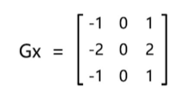

Detect horizontal edge (transverse template)

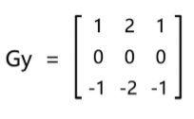

Detect vertical edge (longitudinal template)

The horizontal and vertical gradient approximations of each pixel of the image can be combined to calculate the size of the gradient using the following formula:

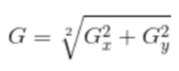

The gradient can then 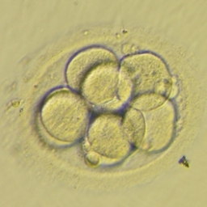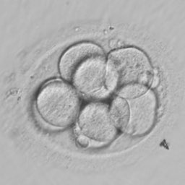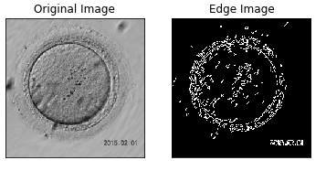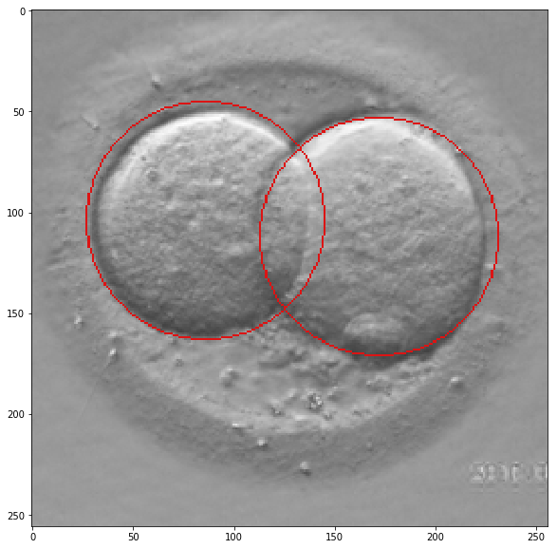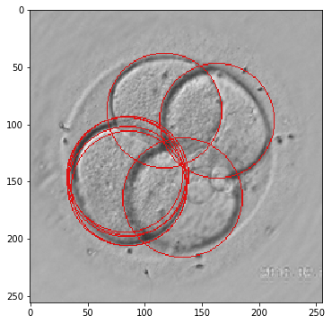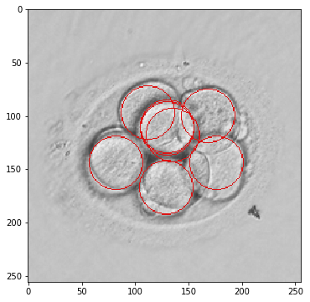be calculated using the following formula:

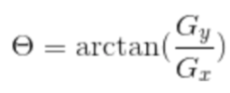

**Sobel Edge Detection**

Sobel edge detector is a gradient based method based on the first order derivatives. It calculates the first derivatives of the image separately for the X and Y axes.

The operator uses two 3X3 kernels which are convolved with the original image to calculate approximations of the derivatives - one for horizontal changes, and one for vertical. The picture below shows Sobel Kernels in x-dir and y-dir:

Sobel operator

1. The Sobel Operator is a discrete differentiation operator. It computes an approximation of the gradient of an image intensity function.
2. The Sobel Operator combines Gaussian smoothing and differentiation.

steps

1.We calculate two derivatives

**1.Horizontal changes**: This is computed by convolving \(I\) with a kernel \(G_{x}\) with odd size.

**2.Vertical changes**: This is computed by convolving \(I\) with a kernel \(G_{y}\) with odd size.

2.At each point of the image we calculate an approximation of the *gradient* in that point by combining both results above:

**3.3.2 Edge Detection using Laplace operator**

Laplace operator is an isotropic operator, second order differential operator. It is more appropriate when it is only concerned with the position of the edge regardless of the pixel gray scale difference around it. The Laplace operator's response to isolated pixels is stronger than the edge or line, and therefore applies only to noise-free images. In the presence 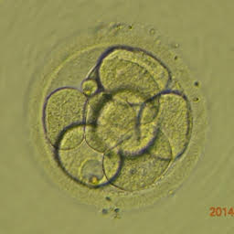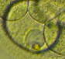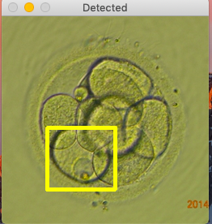of noise, the Laplacian operator needs to perform low-pass filtering before detecting the edge. Therefore, the usual segmentation algorithm combines the Laplacian operator with the smoothing operator to generate a new template. Laplacian operator is also the simplest isotropic differential operator with rotational invariance. The Laplace transform of a two-dimensional image function is an isotropic second derivative, which is more suitable for digital image processing, and the pull operator is expressed as a discrete form:

**Laplacian Edge Detection**

Unlike the Sobel edge detector, the Laplacian edge detector uses only one kernel. It calculates second order derivatives in a single pass.

A kernel used in this Laplacian detection looks like this:

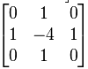

If we want to consider the diagonals, we can use the kernel below:

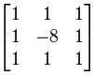

Canny edge detector

The *Canny Edge detector* was developed by John F. Canny in 1986. Also known to many as the *optimal detector*, the Canny algorithm aims to satisfy three main criteria:

* **Low error rate:** Meaning a good detection of only existent edges.
* **Good localization:** The distance between edge pixels detected and real edge pixels have to be minimized.
* **Minimal response:** Only one detector response per edge.

**Steps**

1. Filter out any noise. The Gaussian filter is used for this purpose.
2. Find the intensity gradient of the image. For this, we follow a procedure analogous to Sobel:
   1. Apply a pair of convolution masks (in \(x\) and \(y\) directions:

\[G_{x} = \begin{bmatrix} -1 & 0 & +1 \\ -2 & 0 & +2 \\ -1 & 0 & +1 \end{bmatrix}\]

\[G_{y} = \begin{bmatrix} -1 & -2 & -1 \\ 0 & 0 & 0 \\ +1 & +2 & +1 \end{bmatrix}\]

* 1. Find the gradient strength and direction with:

\[\begin{array}{l} G = \sqrt{ G_{x}^{2} + G_{y}^{2} } \\ \theta = \arctan(\dfrac{ G_{y} }{ G_{x} }) \end{array}\]

The direction is rounded to one of four possible angles (namely 0, 45, 90 or 135)

1. *Non-maximum* suppression is applied. This removes pixels that are not considered to be part of an edge. Hence, only thin lines (candidate edges) will remain.
2. *Hysteresis*: The final step. Canny does use two thresholds (upper and lower):
   1. If a pixel gradient is higher than the *upper* threshold, the pixel is accepted as an edge
   2. If a pixel gradient value is below the *lower* threshold, then it is rejected.
   3. If the pixel gradient is between the two thresholds, then it will be accepted only if it is connected to a pixel that is above the *upper* threshold.

Canny recommended a *upper*:*lower* ratio between 2:1 and 3:1.

**3.3.3 Non Maxima Suppression**

NMS is used to make sure that in object detection, a particular object is identified only once. After edge detection is done on an image we will get multiple bounding boxes for each of the cell, we use edge detection to supress these boxes to obtain only a single bounding box that best bounds the cell.

We run logical and classification algorithm in all grids.It sees probability associated with each detection. The one with largest probability detected first, after which it looks at all overlaps and supresses them.

The way NMS works is :

→ It first discards all those cells where probability of object being present (calculated in final softmax layer) is <= 0.6

→ Then it takes the cell with largest probability among candidates for object as a prediction

→ Finally we discard any remaining cell with Intersection over union value >= 0.5 with the prediction cell.

**3.3.4 Hysteresis Threshold**

This stage decides which are all edges are really edges and which are not. For this, we need two threshold values, minVal and maxVal. Any edges with intensity gradient more than maxVal are sure to be edges and those below minVal are sure to be non-edges, so discarded. Those who lie between these two thresholds are classified edges or non-edges based on their connectivity. If they are connected to “sure-edge” pixels, they are considered to be part of edges. Otherwise, they are also discarded.

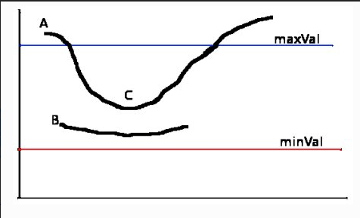

The edge A is above the maxVal, so considered as “sure-edge”. Although edge C is below maxVal, it is connected to edge A, so that also considered as valid edge and we get that full curve. But edge B, although it is above minVal and is in same region as that of edge C, it is not connected to any “sure-edge”, so that is discarded. So it is very important that we have to select minVal and maxValaccordingly to get the correct result.

This stage also removes small pixels noises on the assumption that edges are long lines.

So what we finally get is strong edges in the image.

The Hessian-based FrangiVesselness filter is adopted to detect ridges in the image. Afterwards, it is combined with non- maximal suppression and hysteresis thresholding to extract one-pixel thick ridges. Finally, the small segments in the boundary image are removed.

**3.3.5 Hough Transform**

**3.3.6 Template Matching**

Enhanced template matching technique is developed in an attempt to improve on the poor classifications of the embryos.

**Content of Template**

The template could have contained a disk, whose size corresponds to the size of the blastomeres, it was expected that the matching process would be confused by the overlap of the cells, and so it was decided to design a template with a ring to match the edge of the blastomere. Fig below shows example of a template.The thickness of the ring was created to be similar to the thickness of the cell.

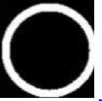

Each image is converted to its binary form after detecting its edges using different edge detection techniques.

As both the image and template are now in binary form, it is less complex and simpler to perform a simple AND operation between the two arrays and then count the number of matches (1s). In this case, the maximum value indicates the position of the best match. As with the previous techniques, all peaks are found for each image when processed with a particular ring diameter, and the redundant ones are eliminated.

The template can be compared with digital edged images got from edge detection techniques, then moving the template over the image will give us the matches with each image.

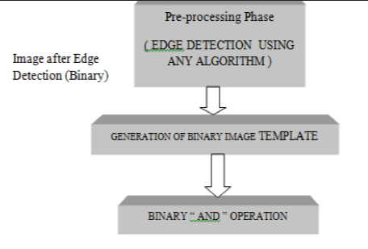

**3.4 Advantages of Project**

**A**utomated embryo grading system replacing a manual embryo grading by an embryologist.

* This can minimize interpersonal errors in grading and hence maintaining uniformity in the laboratory outcome.
* This ultimately lowers the overall cost associated with the time lapsed imaging systems.
* Automated morphological evaluation is likely to save the embryology staff a significant amount of time.Hence the efficiency of identifying the potential embryo for implantation may become easier which will ease the job of embryologists.

**CHAPTER 4**

**REQUIREMENT SPECIFICATION**

**4.1 Software Requirement**

* Python version 3.6
* Anaconda version 3-5.2.0 64-bit

**4.2 Hardware Requirement**

* 4 GB RAM
* Windows 10 Operating System

Language: Python

**CHAPTER 5**

**DESIGN**

**5.1 Data Flow Diagram**

**5.2 Detail Process Flow**

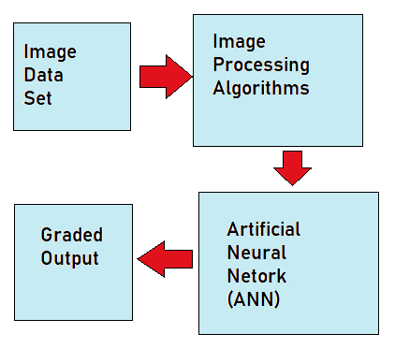

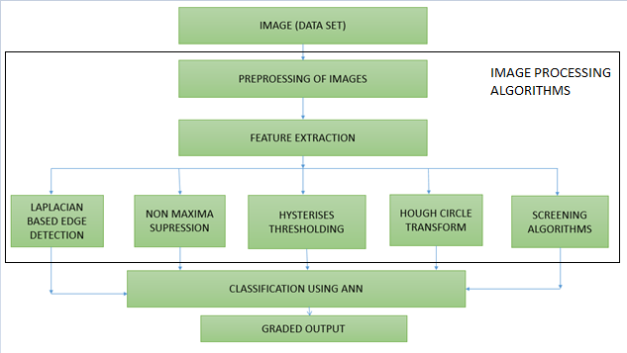

**CHAPTER 6**

**IMPLEMENTATION**

**Preprocessing**

Image Size : 256 * 256

Gray Scaling

————->>>>

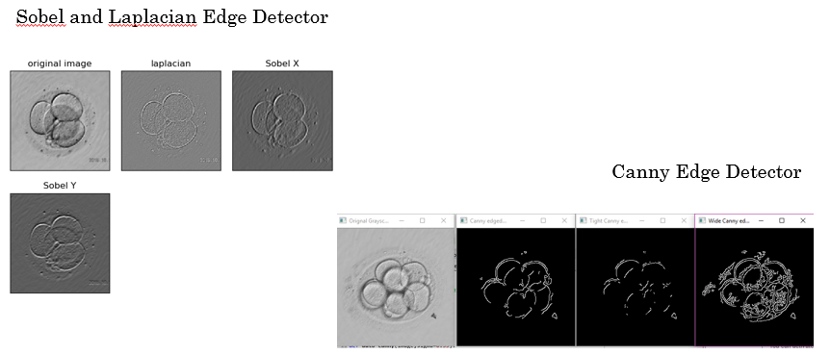

**HYSTERESIS THRESHOLDING**

**TEMPLATE MATCHING**